Topics (pages)

Topics (pages) are free-form content blocks that can be displayed on your site, either embedded within other pages or on a separate page. These are often used for FAQ pages, policy pages, special instructions, and more. To create a custom page, you should create a new topic and enter your custom page content on the topic details page. Content can be written for each language separately.

Topic list

To view the topics, go to **Content management → Topics (pages)**. Search for topics in the topics list by entering the topic text or its fragment in the **Search keywords** field or among all the topics of a certain store.

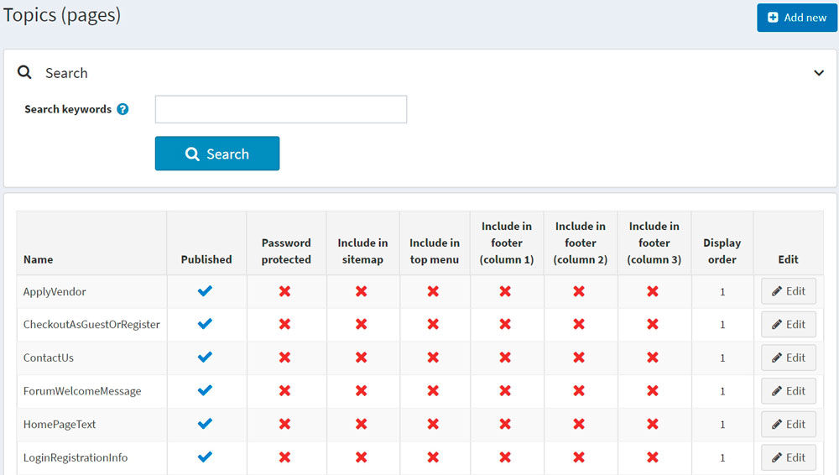

Adding topics

To add a new topic, go to **Content management → Topics (pages)**. Click **Add new** and fill in the information about the new topic.

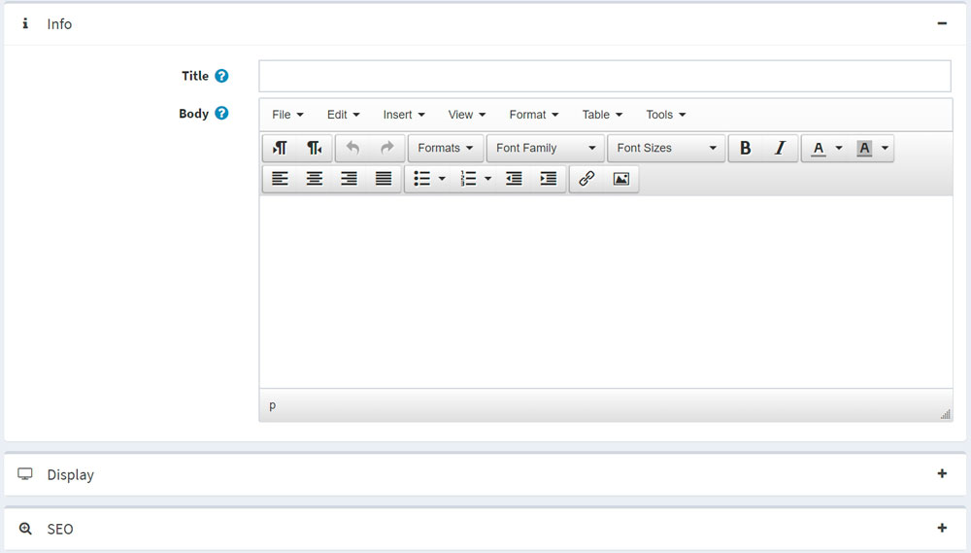

Info

In the *Info* panel, define the following topic details:

* Enter the **Title** for the topic.
* Add the topic content using the editor provided in the **Body** field.
* The **URL** field is there for information only. It is the URL of the topic in the public store. You can edit this by editing the **Search engine friendly page name** field below.

Display

In the *Display* panel, define the following topic details:

* Select the **Published** checkbox to make this topic published.
* You can include this topic in the **top menu**, **footer (column 1)**, footer (column 2), footer (column 3), and **sitemap**. Do this by selecting the corresponding checkbox.
* Select the **Password protected** checkbox if this topic is password-protected. The **Password** field will be displayed on the topic page in the public store. A customer will need to enter the password to access the content of this topic.
* From the **Customer roles** dropdown list, select a customer role or roles that can access this topic.

**NOTE**

In order to use this functionality, you have to disable the following setting: **Configuration → Catalog settings → Ignore ACL rules (sitewide)**. Read more about the access control list [here](https://docs.nopcommerce.com/en/running-your-store/customer-management/access-control-list.html).

* In the **Limited to stores** dropdown list, select stores in which the topic will be displayed.

**NOTE**

In order to use this functionality, you have to disable the following setting: **Catalog settings → Ignore "limit per store" rules (sitewide)**. Read more about multi-store functionality [here](https://docs.nopcommerce.com/en/getting-started/advanced-configuration/multi-store.html).

* Use the **Accessible when store closed** field to make this topic accessible when the store is closed.
* Select the topic's **Display order**. For example, 1 represents the first item in a list.
* Enter the **System name** of this topic.

**NOTE**

It is possible to use the same system name for different topics. For example, you can create two different topics with the same system name and make them accessible for different customer roles. For example, *Guest* and *Registered* customer roles. This means that guests and registered customers will see the different content on the site.

**NOTE**

While editing an existing topic or after clicking the **Save and continue edit** button for a new one, you can click the **Preview** button to see how the topic will appear on the site.

SEO

In the *SEO* panel, define the following topic details:

* In the **Search engine friendly page name** field, enter the name of the page used by search engines. If you enter nothing, then the web page URL will be formed using the page name. If you enter *custom-seo-page-name*, then the following URL will be used: http://www.yourStore.com/custom-seo-page-name.
* In the **Meta title** field, enter the required title. The title tag specifies the title of your web page. It is a code inserted into the header of your webpage, and it is in the following format:
* <head>
* <title>
* Creating Title Tags for Search Engine Optimization & Web Usability
* <title>
* </head>
* Enter the required category **Meta keywords**, which represents a brief and concise list of the most important themes of your page. The meta keywords tag is in the following format:
* <meta name="keywords" content="keywords, keyword, keyword phrase, etc.">
* In the **Meta description** field, enter a description of the category. The meta description tag is a brief and concise summary of your page's content. The meta description tag is in the following format:
* <meta name="description" content="Brief description of the contents of your page.">

Click **Save**. The topic will be displayed in the public store.